3/22/2016

BISWAS, PRIYANKA

KAKARLA MATHAM, DINESH

LANKALA, SAGAR CHANDRA REDDY

NARRA, dILEEP REDDY

NEELAGIRI, NITISH

**ISYS 631 603**

MAYS BUSINESS SCHOOL, TEXAS A&M UNIVERSITY

Design Mockup Report

TEAM 18

Contents

**Design Section** 2

**Screenshots** 2

**Desktop Version** 2

**Mobile Version** 6

**Tab Version** 10

**Design Principles employed** 14

**Golden ratio** 14

**Baby-face bias** 14

**Looking Room** 14

**Responsiveness** 14

**Color Palette** 14

**Incorporation from the User Persona and Design Persona** 14

**From User Persona** 14

**From Design Persona** 14

**Website development** 15

**Software/Tool(s)** 15

**Programming Language** 15

**Hosting Website** 15

**Conclusion** 16

**Performance Evaluation Matrix** 16

**Meeting Schedule** 16

**Project Deliverables** 16

**Learning Expectations** 17

# **Design Section**

## **Screenshots**

The screenshots of the various pages on different versions like desktop, mobile and tab are given below.

### **Desktop Version**

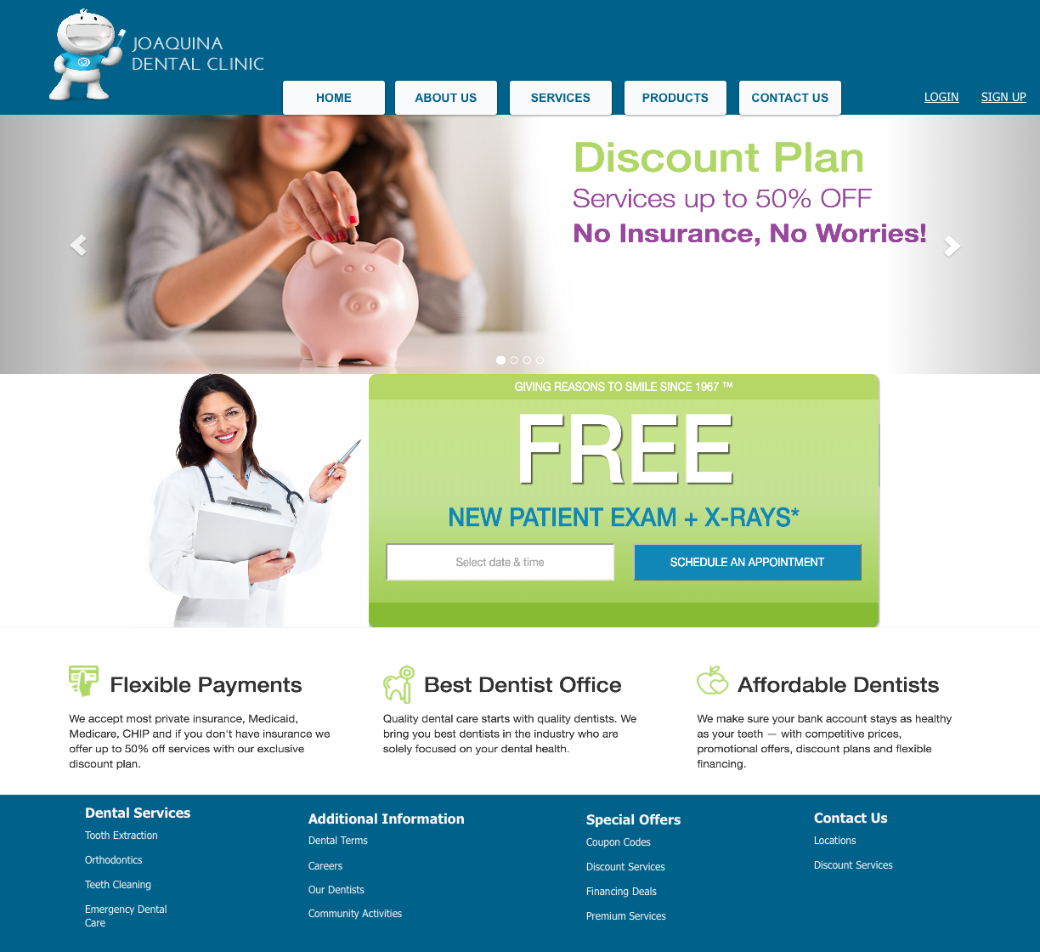

*Home Screen for the Desktop version*

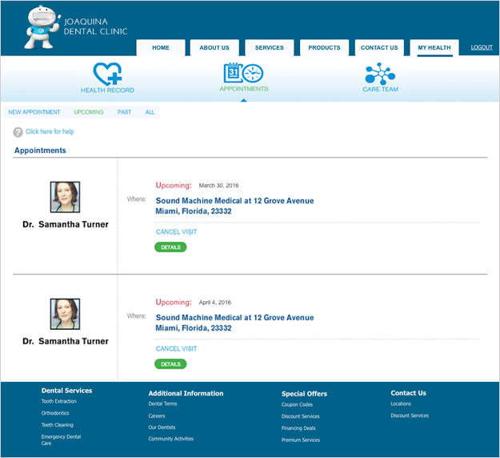

*Patient Screen for the Desktop version*

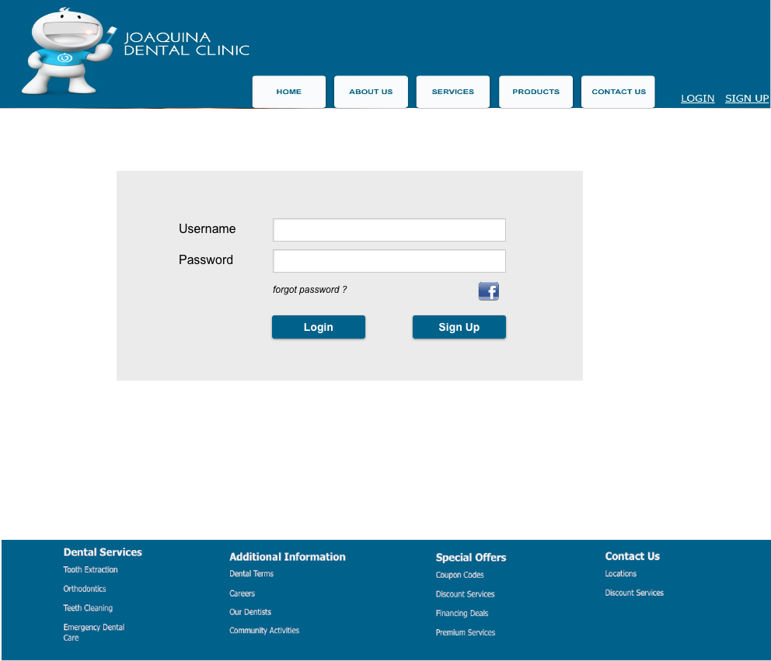

*Login Screen for the Desktop version*

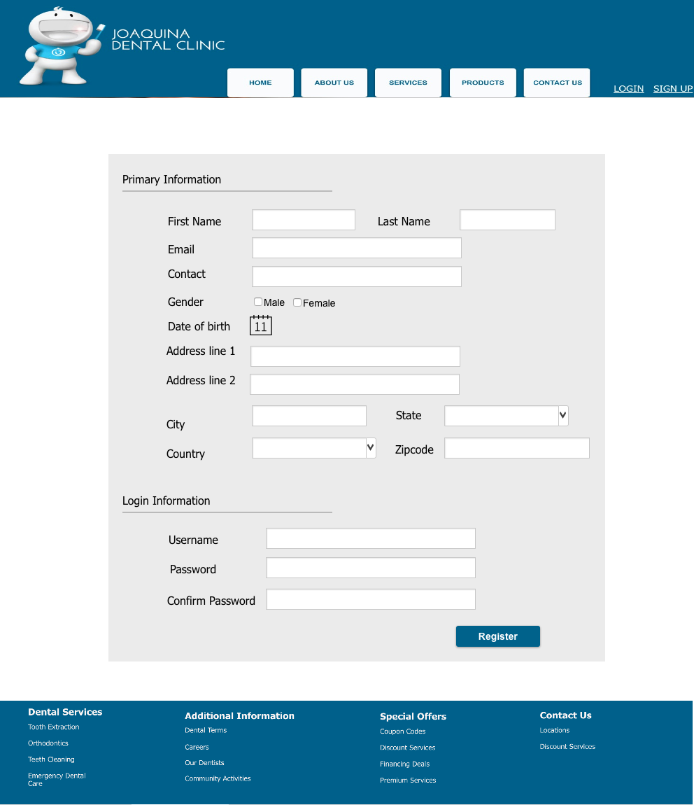

*Registration Screen for the Desktop version*

### **Mobile Version**

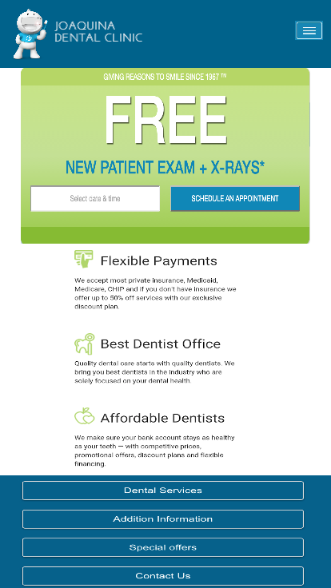

*Home Screen for the Mobile version*

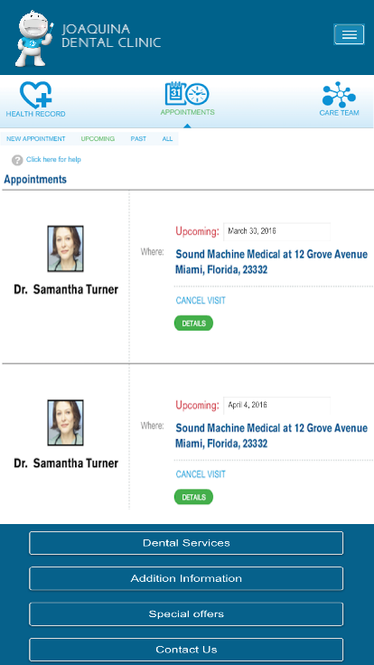

*Patient Screen for the Mobile version*

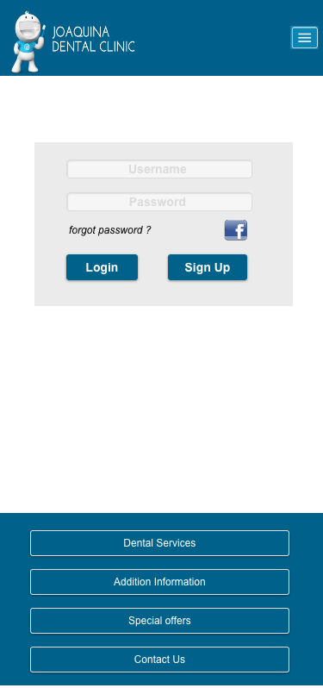

*Login Screen for the Mobile version*

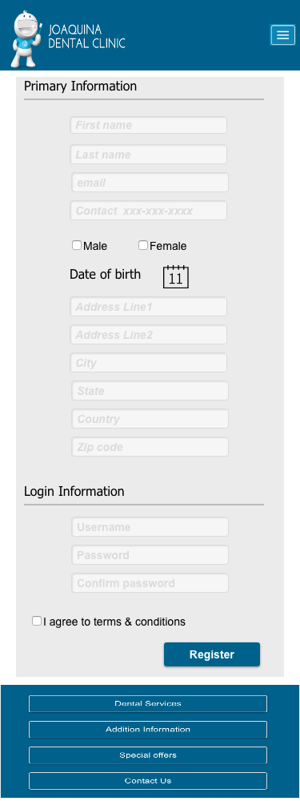

*Registration Screen for the Mobile version*

### **Tab Version**

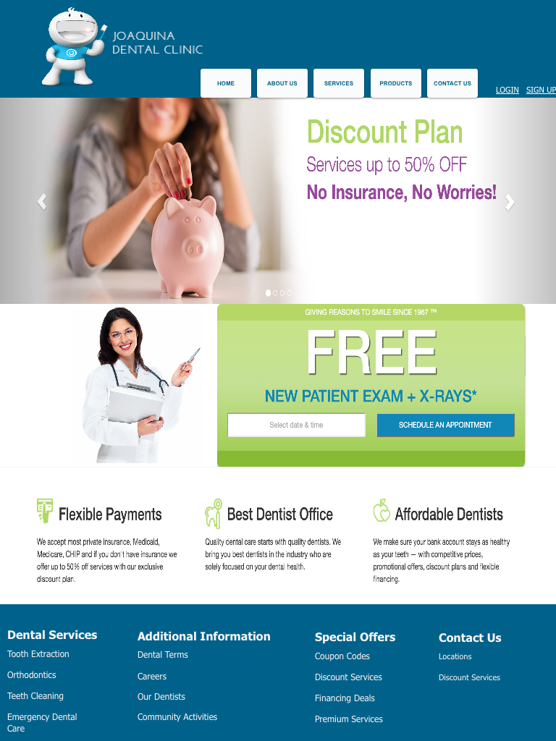

*Home Screen for the Tab version*

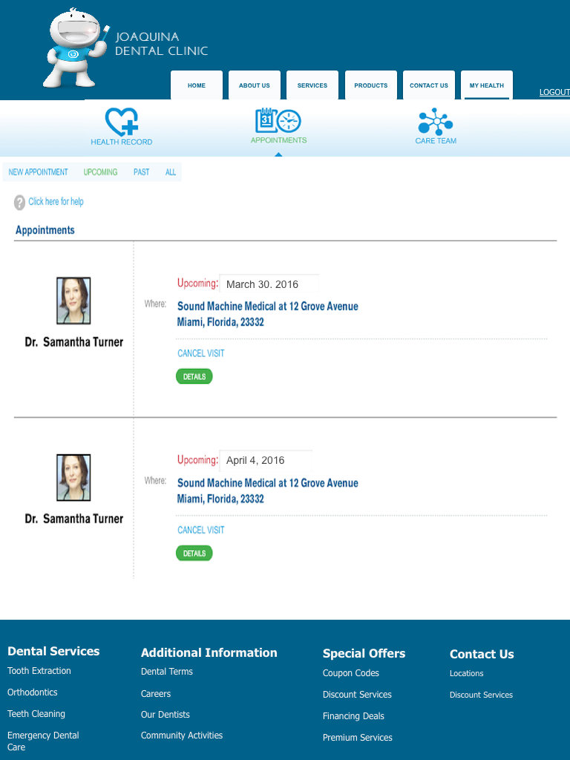

*Patient Screen for the Tab version*

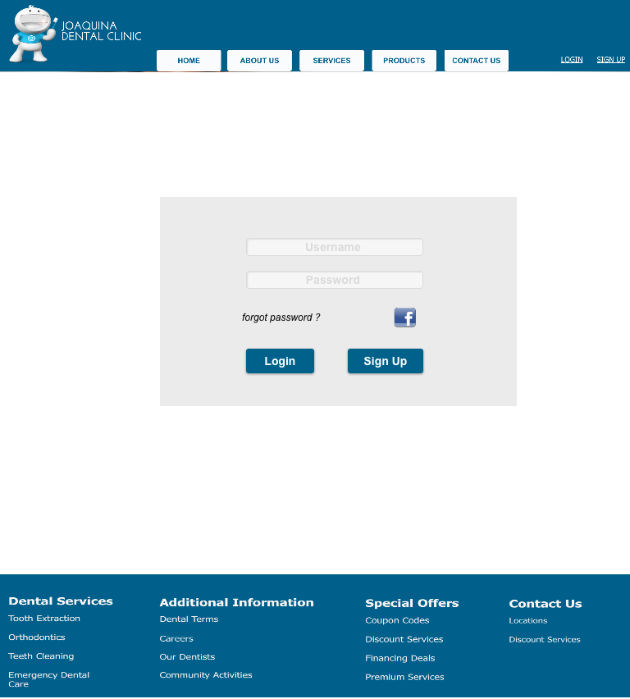

*Login Screen for the Tab version*

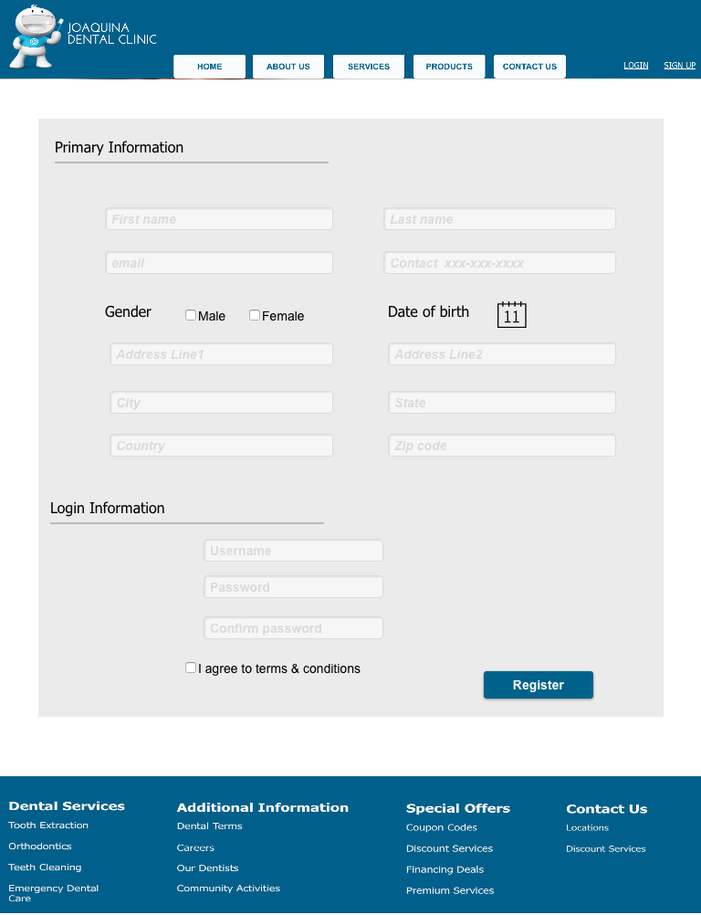

*Registration Screen for the Tab version*

# **Design Principles employed**

### **Golden ratio**

Appointment area in patient view has a golden ratio in that the image of the patient is in 1.618:1 with the content on the right of the image.

### **Baby-face bias**

The baby-face bias is in the logo of the website.

### **Looking Room**

The doctor directs the user towards the appointment section on the Home view of the website. This phenomenon uses the concept of Looking Room.

### **Responsiveness**

The responsiveness is achieved in all the screens of a view across different platforms in that the font size and content areas are aligned with the aspect ratio of the device at hand.

### **Color Palette**

The color palette of the website uses Blue as the dominant color, demonstrating trust and efficiency of the brand. White has been used as a subordinate color to blue and exhibits peace and calmness to the user. Green is an auxiliary color that offers freshness to the user’s experience.

# **Incorporation from the User Persona and Design Persona**

### **From User Persona**

The website has been designed to cater users of different age groups and constitute most of the users of the website. The website particularly engages the users who seek quick actions. It also gives a personal touch to the elderly with clear font and wide content areas.

### **From Design Persona**

Visual Lexicon and Engagement Methods from the Design Persona have been incorporated while developing the mock-up screens. The color wheel has been taken into reference while choosing appropriate colors for various components in the application. The typography of the application maintains a consistent and comfortable outlook with sans serif heading and appropriate weight in the font. The brand traits and the voice of the mascot will be introduced in further views of the website.

# **Website development**

### **Software/Tool(s)**

* Microsoft SQL Server
* Visual Studio

### **Programming Language**

* C#
* ASP.NET
* JQuery

### **Hosting Website**

* Microsoft Azure

# **Conclusion**

### **Performance Evaluation Matrix**

We would like to evaluate the performance of each team member using the below performance evaluation matrix and at the end of the project, each team member would assign points to every other team member. We would be submitting the averages of each team member and if the team member scores more than 95 out of 100, 100% of the team score can be awarded.

|  |  |  |  |  |  |
| --- | --- | --- | --- | --- | --- |
| **Criteria**  **Name of Team Member** | **Took initiative**  (20) | **Attended meetings scheduled**  (25) | **Adequately completed assigned work**  (25) | **Contributed to project completion**  (30) | **Total**  (100) |
| Sagar Lankala |  |  |  |  |  |
| Nitish Neelagiri |  |  |  |  |  |
| Dinesh Kakarla |  |  |  |  |  |
| Dileep Narra |  |  |  |  |  |
| Priyanka Biswas |  |  |  |  |  |

### **Meeting Schedule**

We will be meeting weekly every Wednesday for two hour duration (5.30 PM – 7.30 PM) in West Campus Library (WCL). The frequency of the meetings might be increased depending on the amount of work that needs to be completed.

### **Project Deliverables**

* User Personas
* Design Personas
* Design Mockup
* Project Prototype
* Final Deliverable

### **Learning Expectations**

The IS Design project involves the designing of a website for a dental clinic. Throughout the course of the project we will deliver a variety of deliverables covering various aspects of a website design right from scratch.

The comprehensive nature of the deliverable helps us gain a better understanding of the essential details to be considered while designing an interactive and responsive website.

The various learning objectives include the following:

* Employing various design elements like: baby face bias, effective color scheme, simple design etc.
* Responsive Web Design to make the website compatible with different platforms.
* Typography and effective use of white space, Looking Room.
* Color wheel and its usage.
* Designing a friendly brand mascot.
* Conceptualizing User Schemas.

The course will help us understand and implement the above mentioned features and design an effective website.